SSENDIAS

Sheffield Special Educational Needs and Disability Information Advice and Support Service

Annual Report
1st September 2020 – 31st August 2021

Contents
- Overview 3
  - IASS Duties 3
  - Commissioning, governance and management arrangements 4
  - IASS Budget (Minimum Standards 1.2 & 1.4) 5
  - Service Structure and staffing during this reporting period 6
  - Professional development and training for staff 6
  - Monitoring of Service 7
- Our mission 7
- Operational Functions 8
  - How do we work with parents/ carers children and young people? 8
  - How to contact SSENDIAS 8
  - What do we offer information, advice and support on? 9
  - Working with Young People 9
- Awareness of Sheffield SENDIAS 10
  - How we do it 10
  - Who we are 11
  - Strategic Functions 11
- The data for September 2020 – August 2021 12
- What Our data tells us 14
  - KPI: Service Referrals have increased in comparison to the previous year. 14
  - KPI: Breakdown of reasons for children, young people and their parents contacting SSENDIAS 19
  - Top Reasons Cased by Disability 2021 21
  - KPI: Number of cases in relation to tribunals 23
  - KPI: Service users by age range 23
  - KPI: Service users by Ethnicity 24
  - KPI: Service users by school sector 25
  - Social Media and Website information 28
  - Service Users Evaluation Data 30
- Conclusion 32

Overview
The Local Authorities Information, Advice and Support duties are delivered through the Sheffield SEND Information, Advice and Support Service (SSENDIAS).
SSENDIAS provides impartial, confidential information, advice and support to parents, carers, children, and young people in relation to Special Educational Needs (SEN) and Disability and related health and social care, from age 0 to 25.
IAS Services are key to enabling individual participation, by ensuring that young people and their families have information they need to help them make decisions about services and support they receive.

IASS Duties
Under part 3 of the Children and Families Act 2014, Local Authorities are statutorily required to provide free impartial, confidential, and accurate information, advice and support about education, health and social for children, young people and their parents relating to special educational needs and disability.
Primary legislation is contained within Part 3 of the Children and Families Act 2014 - Sections 19(c), 26(3), 32 and 49. Relevant regulations are the SEND Regulations 2014 and the SEN (Personal Budgets) regulations 2014.
Chapter 2 of the SEND Code 0-25 focuses on the duty to provide information, advice and support to children, their parents, and young people with SEN or disabilities. The Code sets out most of the detail of what the law requires with regard to how services should be commissioned and describes the kind of service that should be provided. SEND Code of Practice: 0 to 25 years - January 2015

‘Local Authorities must arrange for children with SEN or disabilities for whom they are responsible, and their parents, and young people with SEN or disabilities for whom they are responsible, to be provided with information and advice about matters relating to their SEN and disabilities, including matters relating to health and social care. This must include information, advice and support to take-up and management of personal budgets. In addition, carrying out their duties under Part 3 of the Children and Families Act 2014, local authorities must have regard to the importance of providing children and their parents and young people with the information and support necessary to participate in decisions’ COP, 2015 (2.1)

Section 7.4 of the NHSE Guidance for health services for children and young people with Special Educational Needs and Disability (SEND) states

    - A CCG will want to consider with its LA how real-time advice can be accessed by young people and their families. A single point of access for information on services, or on the EHC process, even if organised by the LA, must be

supported by the CCG. Alternatively, the CCG should ensure that their own information, advice and support provision connects with that provided by the LA.

    - All LAs have Information, Advice and Support Services (IASS) (formerly known as Parent Partnership services) in relation to SEND. Services provide advice and support to parents and direct to young people themselves, and are expected to cover education, health and social care information.

    - These services are key to enabling individual participation, by ensuring that young people and their families have the information they need to help them make decisions about the services and support they receive. Since the IASS has broadened its remit, some CCGs are jointly funding their local IASS.

    - In line with other aspects of a CCG’s role, it is useful to provide proactive information on SEND, via leaflets and outreach in key settings. This is essential in settings such as special schools, children’s centres, and outpatient departments. Monitoring the volume and content of requests for advice or of complaints is an important indication for a CCG of key issues or pressures, and the efficacy of the CCG role.

IAS Minimum Standards

The Minimum Standards for IAS services were released in 2018 and supersede The Quality Standards Framework which were put in place for IASSN following the reforms in 2014 with the Children's & Families Act. These standards are used by Local Authorities, IAS Services, other local support services, children, young people and parents/carers to clarify expectations and to determine whether local IAS Service meet good practice or not.
The minimum standards are based on the requirements relating to the key functions that IASS must provide, as set out in the CFA and the SEND Code of Practice.
Minimum StandardsFINAL.pdf

  - Commissioning, governance and management arrangements (Minimum Standards 1.1- 1.8)
    - Joint Commissioning (Minimum standards 1.1)

Section 26 of the Children and Families Act 2014, places duties on local authorities and their partner commissioning bodies to make arrangements to jointly commission and secure provision for children and young people with special educational needs (SEN) or disability. This includes the provision of information, advice and support for children, young people and their parent/carers.

The duties placed on local authorities and their partner commissioning bodies include arrangements for considering and agreeing:
      - what advice and information is to be provided about education, health and care provision
      - by whom, to whom and how such advice and information is to be provided CommissioningGuidance2018.pdf (councilfordisabledchildren.org.uk)
CCG must consider with the Local Authority how advice can be accessed by young people and their parents, Guidance for Health Services for CYP with SEND, p20. Guidanceforhealthservicesforchildrenanddyoungpeoplewithsend
In Yorkshire and Humberside, 20% of IASS are joint funded and joint commissioned. This data was taken from the IASSN funding, casework and staffing data which had 68% return. To compare with other regions, Yorkshire and Humberside are the lowest, with others ranging from 30% to 60%. In Sheffield we have a joint commission, but we are not jointly funded. We are in the process of asking for additional funding from LA and CCG.

    - Steering Group (Minimum Standards 1.7- 1.8)
The service Steering Group meets twice a year to look at and feed into the development plan to give a better strategic oversight and governance arrangements, and a shared clear vision with key-stakeholders, with agreed intended outcomes for the service taking account of IAS statutory duties and minimum standards.

  - IASS Budget (Minimum Standards 1.2 & 1.4)
SSENDIAS core funding of £234,500 is centrally funded by the local authority to provide 6 FTE staff. This budget is used solely for Sheffield SENDIAS. In addition to the budget the service has relied upon short-term grant funding to manage workloads since 2018. This funding ceases in March 2022 which leaves limited resources to enable ongoing full compliance with the minimum standards.

1.4.1 Grant funding history

In April 2018, the DfE commissioned the Council for Disabled Children (CDC) to manage grant funding to improve IASS to meet the new Minimum Standards. Sheffield was successful in this bid and secured £32,000 grant funding, which enabled the service to recruit an additional caseworker. Freeing up the time of the SSENDIAS Manager to enable them to fulfil their strategic duties under minimum standards
SSENDIAS successfully applied for and was successful in securing further funding of: 2019/20 £44,090

2020/21 £27,882
2021/2022 £10,000

This funding maintained the staffing hours for the additional caseworker until January 2021. Due to raising the service profile and an increase in demand we then reviewed the service structure and roles. A YPIO was then temporarily added to further our efforts to enhance on the minimum standards we were meeting. Unfortunately, the person in the YPIO role gained permanent employment and leaves the service in Oct 2021. Due to the nature of the funding and amount of time left we have been unable to fully tests the remit or refill this role.

Service Structure and staffing during this reporting period
Service Manager, Sally Morrison, FT 1.0
3 x Caseworkers Tracey Gillin, FT1.0 Sue James, FT1.0 Linda Wright, FT1.0
Young People’s Involvement Officer Olivia McGeeney, FT1.0, temporary until March 2022 but leaving Oct 2021
2 x Information Officers
Lucy Wilks, FT1.0
Emma Bagshaw, FT1.0

  - Professional development and training for staff (Minimum Standards 4.1-4.3)
The service places a high importance on developing and maintaining professional competence and ethical practice in providing accurate, impartial information, advice, and support to families.
To be compliant with the IAS Minimum Standards, all staff providing IAS have successfully completed all 3 levels of online IPSEA legal Training within 12 months of joining the service and attend National IASS training and other training opportunities made available that is necessary for the development of personal practice development. Minimum Standards 2018 – 4.1
Staff participate in individual supervision and professional development reviews. This provides a regular opportunity to develop their knowledge and skills through shared practice and develop expertise in giving information on SEND legislation and guidance Minimum Standards 2018 -4.3
Staff are expected to maintain and develop their own knowledge of national and local practice including local provision and developments within the city and are expected to research information on matters of SEND, legislation and case law to provide the accurate and impartial information. In additional to self-learning the service manager and other members of the team play a key role in cascading relevant information to the team.

  - Monitoring of Service (Minimum Standards 4.2)

To ensure good quality service delivery of accurate information, advice and support we:
    - Audit casework activity
    - Complex case supervisions
    - Monthly evaluations to service users
    - Review minimum standards for SSENDIAS
    - Formal monthly supervision procedures
    - Annual PDR’s (performance development reviews)

Our mission

The service aims to:
- Provide parents, children, young people and professionals with accurate unbiased information, which is at an arm’s length, confidential, impartial, dedicated and easily identifiable service.
- Deliver the service in line with the National Minimum Standards which take into account tasks from chapter 2 of the SEND Code of Practice.
- Promote and maintain good partnership working between children and young people, their parents and carers, professionals, the local authority, educational settings and health
- Work to improve early intervention for support in schools and improve communication between involved schools and services.
- Provide a range of flexible services for children and young people who have Special Education Needs & Disabilities (SEND) and their parents/carers, to have access to impartial, clear and relevant information, advice and support in order for them to:
  - play an active and informed role in their/their child’s education and preparation for adult life and to support each other,
  - make informed choices and play an active role in decisions about their SEND
- Provide advocacy support for individual children, young people, and parents/carers empowering them to express their views and wishes and exercise their rights in matters including exclusion, complaints, SEND

processes, and SEND appeals etc. IASS - Definition of Advocacy.docx_0.pdf (councilfordisabledchildren.org.uk)

- Voice the views of parents and young people, to ensure that their voices directly influence the development of local SEND services, policy and practice.

- Operational Functions (Minimum Standards 3.1- 3.6)

How do we work with parents/ carers children and young people?
To meet the IAS operational requirements SSENDIAS supports children, young people and families on all aspects of the child or young person’s education and related health and social care matters. It covers all children and young people (0-25) with SEN and Disabilities, with or without a diagnosis.

  - How to contact SSENDIAS (Minimum Standards 1.3, 3.1, 3.2, 3.3, 3.6)

    - Direct phone/ advice line 0114 2736009, which provides confidential, impartial advice. This is available Monday to Friday 9am-5pm with the facility to leave a voicemail at all other times.
    - E-mail ssendias@sheffield.gov.uk
    - Facebook Sheffield SEN & Disability Information, Advice & Support - Home | Facebook
    - Instagram Sheffield SENDIAS (@sheffield_ias) • Instagram photos and videos
    - Standalone website Sheffield SENDIAS - Special educational needs and disability advice and support
    - Sheffield Local Offer SSENDIAS - Sheffield SEN & Disability Information Advice and Support | Sheffield Directory
    - Weekly Information sessions to help parents/ carers and young people develop their knowledge and understanding Training and Events — Sheffield SENDIAS
    - Face to face or Virtual meetings
    - Information leaflets to help parents and young people develop their knowledge and understanding.
    - Information about other agencies, e.g., voluntary agencies and health services which can offer information and advice about their child’s particular SEN and Disabilities

What do we offer information, advice and support on?
    - Support throughout the statutory processes in relation to Education, Health and Care Plans.
    - The Special Educational Needs and Disabilities (SEND) laws, systems and processes
    - Explain national and local SEND policies and your rights & responsibilities around these.
    - Support in resolving disagreements, mediation and Tribunals to the First Tier Tribunal. Including attending the hearing as a helper/ advocate if the parent/ carer or young person requires us to (Minimum Standards 3.5)
    - Support Early Intervention in schools to help parents understand SEN support and what that means for their child/ young person in their educational setting.
    - Support in the preparation for and/or attendance at meetings where necessary and/or appropriate
    - Support to empower parents/ carers, children and young people on a range of topics to help them fully understand the SEND processes and be able to get their voice heard in all decisions made for the child or young person around their education
    - Advocating and supporting young people to enable their voice to be heard and to be part of/represented in education decision-making (Minimum Standards 3.4) IASS - Definition of Advocacy.docx_0.pdf (councilfordisabledchildren.org.uk)
    - Exploring with individuals the options open to them at any given point in their child/ young person’s education, including the options on the range of educational settings in Sheffield and out of City
    - Help to understand professionals’ reports including EHC Plans
    - Information, advice and support with exclusions including attending GDBC (Governing Body Disciplinary Committee) and IRP (Independent Review Panels) with parents/ carers and young people
    - Complaints against settings, Local Authority, NHS or Social Care (in relation to education) following the processes laid down by each service. With escalation to Local Government Ombudsman if required.
    - Offering generic SEND advice, information and bespoke training to schools, and other services (Minimum Standards 3.6)

  - Working with Young People (Minimum Standards 3.4)

Over this year we had a new member of staff who started on a temporary basis as a Young People’s Involvement Officer (Feb 2021- Oct 2021). During this time, we started to work directly with the young person if we received a referral from parent/ carer or young person themselves. This role was to support PFA (preparation for adulthood). The role was to:
    - To provide advocacy for young people (from Y9) involved in SEND processes, to provide confidential information advice and support around a range of education, health and social care matters relating to their SEN and disability

    - To enable young people to be part of and be represented in education decision- making with LA, Educational Settings, and other relevant organisations.

    - To develop projects to support and enable the active involvement of young people in planning, delivery, monitoring and evaluation of SENDIAS services in Sheffield.

    - To develop, in partnership with other agencies and community groups, effective tools and methods which enable meaningful consultation and involvement with and young people

    - To offer training, support, and guidance to people working with young people within Sheffield to engage those young people in consultation and involvement activity around SEND.

After training and liaising with other Young People Officers from SENDIAS services in the region this work had started to grow. We had a plan of awareness sessions to start in September but due to the post holder finding permanent employment and a lack of sustainable funding, we have had to put some of the work on hold.
All existing caseworkers will take over the referrals for Y9 and post 16 along with the other referrals in line with areas of the city they cover. They ensure when supporting they talk to the young person to get their voice heard in all decisions made for their education. They will:
    - provide advocacy for young people (from Y9) involved in SEND processes, to provide confidential information advice and support around a range of education, health and social care matters relating to their SEN and disability

    - enable young people to be part of and be represented in education decision- making with LA, Educational Settings, and other relevant organisations.
- Awareness of Sheffield SENDIAS (Minimum Standards 1.6, 1.7, 3.2)

How we do it
To ensure SSENDIAS is a widely known by potential service users, Head teachers, FE principals, SENCos, SEND Teams, children’s and adult social care, health

commissioners and providers. We have a program of awareness sessions; some we liaise with the LA and NHS. We also ensure we are easily accessed through different formats. We have representatives from all stakeholders on SSENDIAS steering group.
Awareness is city wide:
    - Early Help Training for all LA practitioners
    - Ryegate recently diagnosed parents’ group. This is on hold presently due to COVID
    - Family Action ADHD Group
    - Sheffield Parent Carer Form
    - SENCO and Head Teacher training sessions through Learn Sheffield
    - Sheffield College and other post 16 providers
    - Voluntary and charity parent/ support groups
    - Parenting groups
    - Healthwatch Information Session’s
    - Single point of access for Neurodevelopmental for Autism and ADHD referrals
    - Sheffield Local Offer
    - Social Media
    - Children Disabilities Register
    - Stand-alone website
The awareness sessions are held through coffee mornings, lunchtime seminars, information sessions, 1:1 session, twilight sessions for schools, team meetings. These are done face to face and virtually.
We have a clear referral policy and procedure which is available on our website. Sheffield SENDIAS Referral Policy and Procedure.pdf

  - Who we are (Minimum Standards 1.5)

Sheffield SENDIAS had a rebranding in September 2020 to ensure we are easily identifiable and separate from the Local Authority. We are an in-house service and over the year we have quarterly commissioning meetings.
When new referrals come into the service the parent/ carer or young person will receive an initial information pack. This contains our policies: GDPR Consent, Service Policy, how we can help and an information leaflet on what is impartial information, advice and support. We monitor how we are seen by service users through evaluations. If a member of the team speaks to another professional about the child/ young person, we will always ask for permission if this hasn’t been received from initial information pack.

  - Strategic Functions (Minimum Standards 2.1- 2.3)

Sheffield SENDIAS has a manager that is based solely within the service without any other responsibilities from the LA/CCG. The development of the service and delivery has been the responsibility of the manger with input from the SSENDIAS steering group, Sheffield PCF.
Sheffield SENDIAS is a member of:
    - The IASSN (information, advice, and support service network) which provides peer support on issues affecting the delivery of the Information, Advice and Support Services throughout England

    - The Northern User Group for SEND Tribunals

    - We attend national, regional, and sub-regional meetings with neighbouring IAS services.

    - We work with Sheffield PCF and other support groups such as Family Action ADHD Group, Sparkle, Autism Hope Group. We inform and influence policy and practice by sharing service feedback and raising concerns of families with the relevant department. We share anonymised data and provide cases studies.

    - Co-production of information provided by Sheffield LA for families around SEND. We attend task and finish groups and working groups.

    - Peer support with sub regional IAS- Barnsley, Rotherham and Doncaster. Also, Derbyshire, Leeds, and York. This is both offering peer support and receiving it.

The data for September 2020 – August 2021
Over this year we have been working from home due to restrictions and challenges from COVID-19. This has meant major changes to way that we were working, and although we have managed some face-to-face meetings, coffee mornings and information sessions most of our work is still done remotely and virtually.
The demand for information, advice and support has continued over this academic year with peaks and troughs in months due to changes in the restrictions and whether the children/ young people are in their education setting.
We have continued with an increase in the number of referrals coming into the service from parents/ carers and young people. For Sheffield SENDIAS to manage the increase in cases we are proposing changes to our ways of working. The changes will start in the new academic year Sept 2021. The reasons for the changes are due To the increase in referrals, which for the first time ever has led to waiting lists for referrals to be actioned and allocated- currently around 3 weeks. As some of the caseload is statutory with timescales, this has meant that some cases have had to be prioritised over other to ensure they have been dealt with within timescale. In

order to try and balance this we have introduced a tiered level of support for new referrals and will be starting weekly information sessions.

A 3-tier system:
    - Tier 1- (level 1 intervention) This is an Information Officers role. Telephone advice with an Information Officer who will sign post and offer basic advice around relevant information and services. Then following up if needed with an email containing the information and links to what has been discussed
    - Tier 2- (level 2 intervention) This is Caseworker, TARA enhanced Information Officer. A discussion with a caseworker/ YP IO/ TARA IO who will offer a telephone consultation and if needed a virtual meeting to discuss in more detail if further information is needed after a tier 1 call.
    - Tier 3 (level 3 & 4 intervention)- This is Caseworker. Allocated to a caseworker for support through statutory processes. Such as:
      - EHC Plan assessment requests
      - Mediation
      - Tribunals
      - Exclusions
      - SEN support in school

SSENDIAS Newsletter
In the new academic year, we will be launching a termly newsletter. This will include lots of useful information from SSENDIAS and Sheffield for children and young people with SEND and their parents/ carers
- Meet the team
- What’s new in SSENDIAS
- Dates to remember for key statutory processes
- What’s going on around Sheffield
- News from voluntary and charity groups
- How to contact SSENDIAS
- Useful contacts
These are just some of the topics which will be themed depending on the time of year. The newsletter will be available through:
    - Social media and website
    - If registered on the Childrens Disability Register
    - If signed up for receiving the newsletter
    - Sent out to other stakeholders and colleagues

What Our data tells us
The COVID-19 pandemic must be taken into consideration for all figures. Since March 2020 there have been restrictions with National & Local lockdowns and easing of these restrictions at various times. The referrals for SSENDIAS have increased this year in comparison to previous years. SSENDIAS has continued to work with parents, schools and other agencies.

KPI: Service Referrals have increased in comparison to the previous year
Referrals received in 2020-2021 have increased by 6% from those received in the previous academic year, going from 1554 to 1649.
Figure 1: Referrals to service by academic year
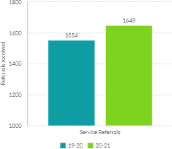

The graph below shows a breakdown of referrals received each month across the academic years 19-20 and 20-21. We can see that they were at the lowest in April 2020 which was the first full month of the first national COVID-19 lockdown, and they were also lower in January and February 2021 when another national lockdown was imposed. This chart demonstrates the way referrals peak at different times throughout the year.
Figure 2: New referrals received by month
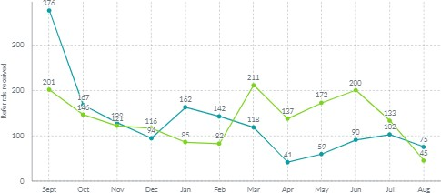

This graph demonstrates the level of active referrals in the service across 20-21. It demonstrates the increase in caseloads across the year as we end the year with 80 (22%) more active cases than we started with.
Figure 3: Cases active within each month for academic year 20-21
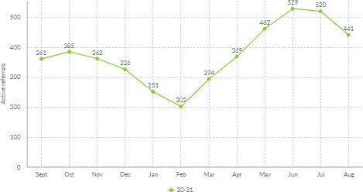

Referrals, Professional and Anonymous Enquiries Referrals
Referrals to the service are varied in complexity and may require ongoing support over a lengthy period of time or just require a single conversation to provide advice and information to increase parents and a young person’s knowledge.

Professionals
These are “one-off calls’ from professionals, educational settings, health, Local Authority and other stakeholders for advice and information. The service does not collect a child’s details from professionals due to confidentiality and working at arm’s length. We will offer generic advice.

Anonymous
These are from parents/ carers or young people are ‘one off calls’ where a parent doesn’t want to leave details, is just wanting a quick question answered or signposting to the right service. We do not collect personal data for this.

Figure 4: Referrals, Professional and Anonymous enquiries
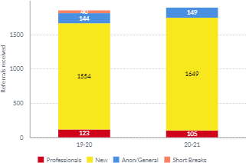

From the chart above we can see that referrals from professionals decreased slightly between 19-20 and 20-21 but both new referrals and anonymous enquiries increased. There were no short break enquiries in 20-21.

Intervention Levels

Each referral is categorised into four levels of intervention to provide a tiered approach to casework demands. The interventions levels were created by the IASS Network in 2016 and recommended to use as a strategic case management tool and to use in the IASSN benchmark data report.
Levels 1- 4 are used by IAS Services to capture the extent of involvement and support provided through a range of interventions dependent upon the individual characteristics of the case. Support is offered at a level according to the individual need of the parent/ carer or young person and the level of disagreement that exists regardless of at what stage of the Code of Practice their child/young person is placed. Intervention levels for IASS August 16
Since the increase in service referrals, we have less capacity to support at higher levels of intervention which is demonstrated in the graph below. Cases supported at Level 2 have nearly doubled whereas cases at level 3 and 4 have both decreased.
Figure 5: Intervention levels of referrals received
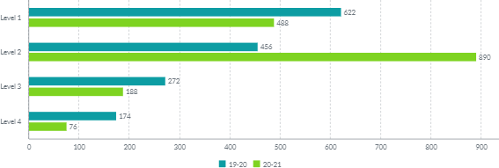

How did you hear about SSENDIAS
We track how service users find out about SSENDIAS. We have a number of parents/ carers who return to SSENDIAS at different times in their child/ young person’s education. This shows confidence with using the service. This year’s data shows a varied group of practitioners, services and educational providers are signposting to the service and word of mouth from other parents.

Figure 6: How did you hear about SSENDIAS?
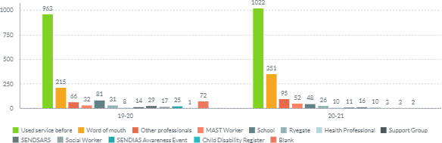

Contact Method
Telephone is still the preferred method of communication for parents, but email has increased year on year.
Figure 7: Contact method
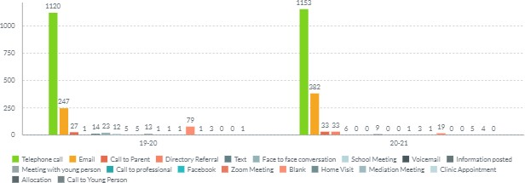

Number of referrals by referrer
The service only accepts referrals from parents/ carers or young people. Only in exceptional circumstances will we receive a referral from a school or Practitioner. This is only when we can ascertain permission has been sought for the referral to be accepted. Sheffield SENDIAS Referral Policy and Procedure
Figure 8: Number of referrals by referrer
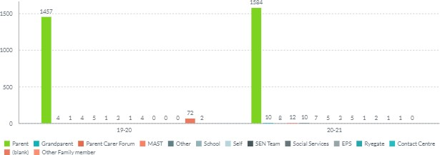

Referrals By Postcode
We have looked at mapping against the population of Sheffield of the number of children and young people 0-25 who have SEN and/or EHCP against our referrals by postcode. It did show that within the areas of S3 & S4 were the lowest referral rates compared to other areas. Referrals were 2.4% being the lowest to 9% being the highest. Since this we have started to look at the harder to reach communities to raise awareness of the service.
Figure 9: Referrals received by postcode
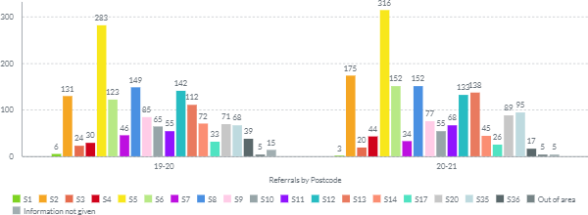

Referrals by Locality
The mapping of the referral data will feed into the Localities with the lowest number of referrals. These will be targeted in any awareness we do for the service.
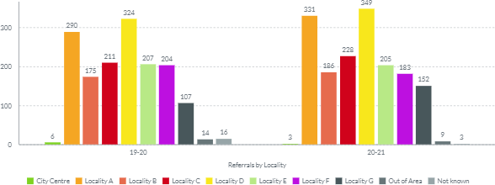
Figure 10: Referrals received by Locality

Referrals by Gender
The over representations of boys over girls is a historical picture that has been seen locally and also follows a national trend.
Figure 11: Referrals received by gender 19-20 Figure 12: Referrals received by gender 20-21
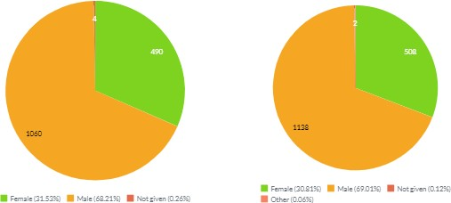

KPI: Breakdown of reasons for children, young people and their parents contacting SSENDIAS
This data gives us information about the initial reason a parent/ carer or young person contacts the service. This may change over the time we are supporting a parent.
SEN Support related enquiries remains the most common reason why parents contact the service. Concerns raised include matters relating to a child/young person’s SEND, provision and/or the lack of progress in attainment. Where parents felt their child’s SEN was not recognised by school, unsure if their child was registered has having an SEN or were unsure of the support in place. Service users contact the service for support in meetings or for pre-meeting advice to identify options or how they may best approach difficult conversations in a structured way. Often this gives the service user more confidence in their self-advocacy skills and promotes their involvement in decision making. This is our highest levels of request for support.

Statutory work such as requests for a needs assessment for an EHC Plan, contents of plan, placement named in plans, content of plan, mediation and tribunal support remains consistant reasons for referral. Over this year we have worked collabertively with SENDSAR’s to look at EHCNA Conflict resolution meetings. These will be offered to parents as another route of redress which can be used prior to mediation and tribunal. These meetings are due to start being offered in Autumn term 2021.
Figure 13: Top reasons for referrals 20-21 by percentage of total referrals received
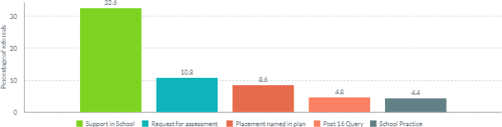

These top 5 reasons combined make up 61.2% of all referral reasons for the academic year 20-21.

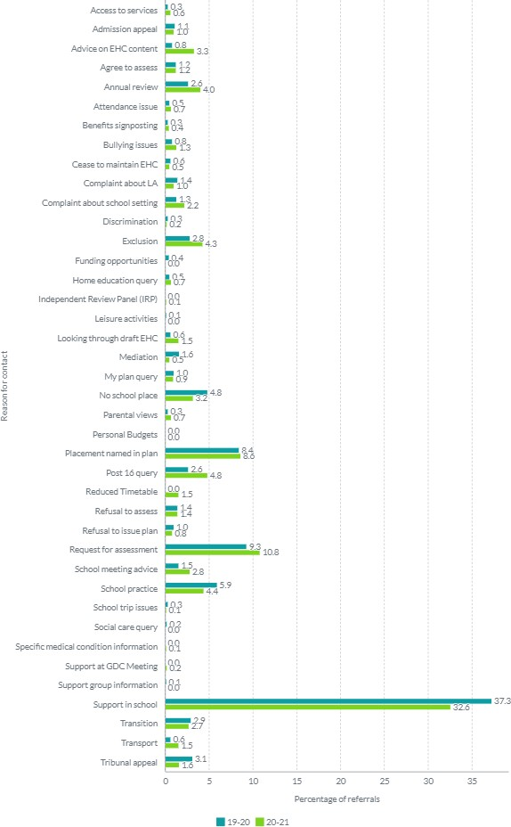
Figure 14: Reasons for referral by percentage of referrals received

Top Reasons Cased by Disability 2021
Referrals in all groups of type of need, have increased on those received in previous years. The largest referral group has been for those with a diagnosis of ASD, 51%, (Autistic Spectrum Disorder) and ADHD, 16.4%, (Attention Deficit Hyperactivity Disorder), referral numbers continue to increase for these groups. This continues to make up a significant proportion of our case load.
We also receive a high number of children who have no diagnosis. Unconfirmed SEND is those on pathways for assessments or where parents have concerns about their child’s development and unsure what support is in place. Our role is to link parents with professionals and services at the early identification of the child’s SEN. The service continues to play a key role in brokering discussions between families, educational settings and services to open discussions. Parents report that the child cannot have support because their child does not have a diagnosis. We have recently added into this field awaiting assessment, for this academic year we did not capture this data.

We have seen an increase this year with children and young people who have anxiety and mental health issues
Figure 15: Top reasons cased by disability 20-21 by percentage of referrals received
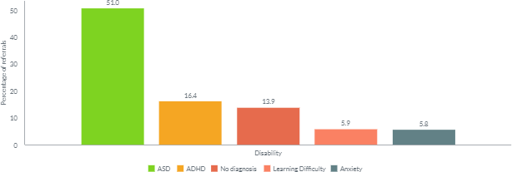

Figure 16: Referrals by disability by percentage of total referrals received
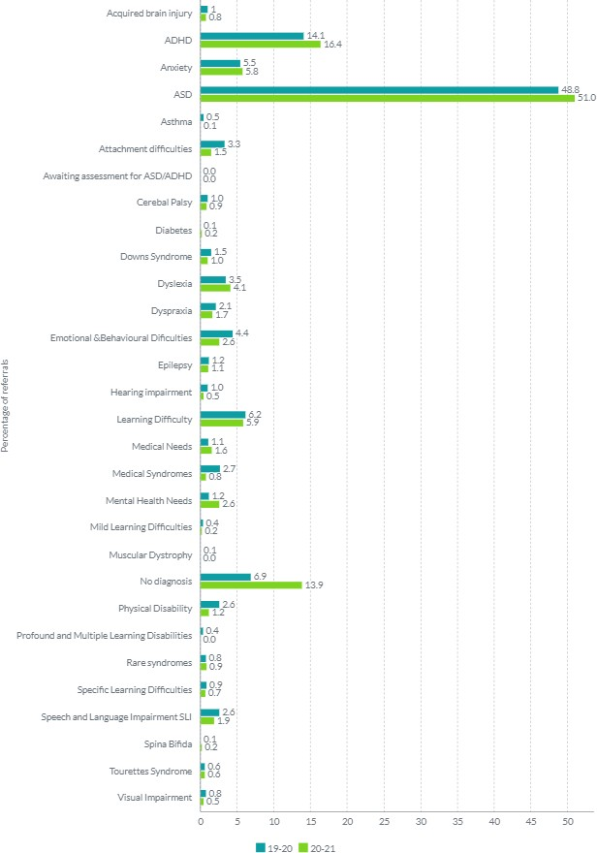

KPI: Number of cases in relation to tribunals
SSENDIAS continues to support parents/ carers and young people in tribunals attending as a helper/ advocate to help them navigate, understand the complex process and to challenge Local Authority decisions where there is a difference of opinion.
These tribunals are in relation to:
    - Refusal to assess
    - Refusal to issue an EHC Plan
    - Refusal to amend a plan following an annual review
    - Content of a plan
    - Placement named in a plan
    - Cease to maintain a plan
We work in partnership to resolve disagreements. A strength of the service is the work and involvement around enabling parents to resolve disagreements with their child’s school/setting or the LA when things go wrong, or to understand, or challenge decisions, or the SEN arrangements made for their child. SSENDIAS also offers support at formal mediations which is option for parents/carers and young people to take.
The success of reaching an agreed outcome is based upon a wide range of factors but most crucially; parents and young people’s understanding of processes, supportive in making an active contribution in meetings and the skills and knowledge within the service and the professional relationship we have with the LA and educational settings.

This tells us how many referrals we have supported with tribunals. Some of which will have gone to tribunal hearing, but others may have been conceded by the Local Authority prior to hearing. This is usually close to tribunal hearing dates, therefore still counted as full tribunal work due to complexities around this type of support.
Figure 17: Tribunals heard within each year
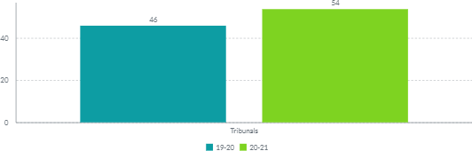

KPI: Service users by age range
The majority of our referrals come from statutory school age children in mainstream settings. This is in line with previous year. However, the numbers of referrals are

increasing year on year in all age ranges. In the academic year 20-21 45.48% of referrals were for primary age children and 34.87% were secondary aged children.
Figure 18: Age range of service users 19-20 Figure 19: Age range of service users 20-21
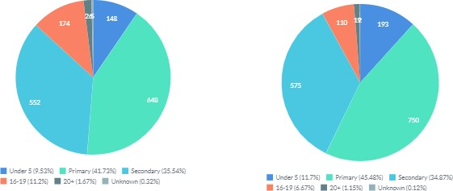

KPI: Service users by Ethnicity
We monitor ethnicity to look at where and what communities are accessing our service. As expected, the majority of service users are white British, but since monitoring we can show that we receive a broad range of referrals from all ethnicities. It would be wrong to make simplistic assumptions that this is disproportionate without seeking information of numbers of children from all ethnicities with SEND, to map our referral data against. This will be looked at once we have consistent data. Currently we have only been collecting this for just over a year, therefore in 2019-20 the data is primarily unknown, so we are unable to make any comparisons at this point.
Figure 20: Service users by Ethnicity
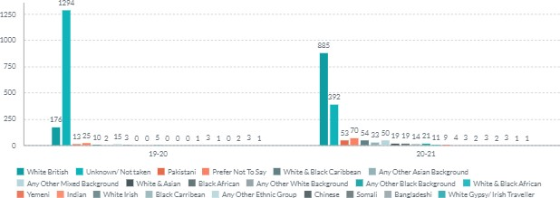

KPI: Service users by school sector

Referrals by Educational settings
The greatest number of referrals concern mainstream primary and secondary school children, which is consistent to previous years. However, we do have referrals from all age ranges in all settings including Special schools and integrated resources. There are a number of children who are not a Sheffield school or not in a school setting. There are various reasons such as Elective Home Education, recently moved in the area, no school placement or attend out of city due to living close to Sheffield borders or suitability of a school for their needs. We support children who attend schools out of the city and live in a Sheffield postcode. We have the same support from bordering SENDIASS, who support children cross borders, who attend Sheffield Schools but live in neighbouring authorities.
Figure 21: Number of referrals from each type of school Figure 22: Number of individual settings
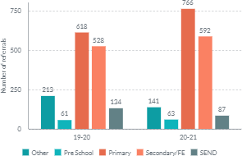
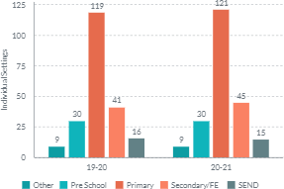

Over the years we have a few educational settings where referrals are higher than other schools. This can be for several reasons:
    - Greater awareness of SSENDIAS
    - Lack of parental confidence in the support their child is receiving
    - Concerns with local policies being followed for statutory processes
    - Risk of exclusion
    - Communication breakdown with education setting and parent/ carers
This data is used to feed into school improvement, raising concerns or championing good practice within a school. As a service we may also offer parent coffee mornings to schools for 1:1 session, group discussions or training for parents/ carers and professionals

Figure 23: Primary Schools with most referrals across two years
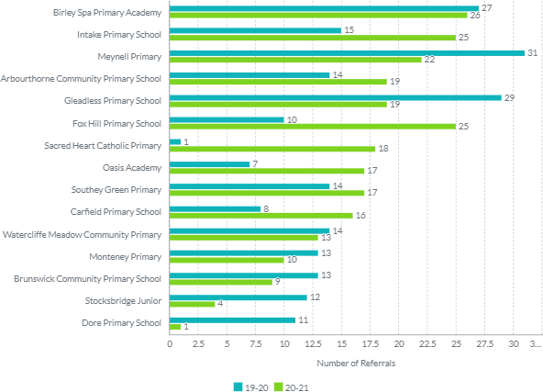

Figure 24: Secondary/FE Schools with most referrals across two years
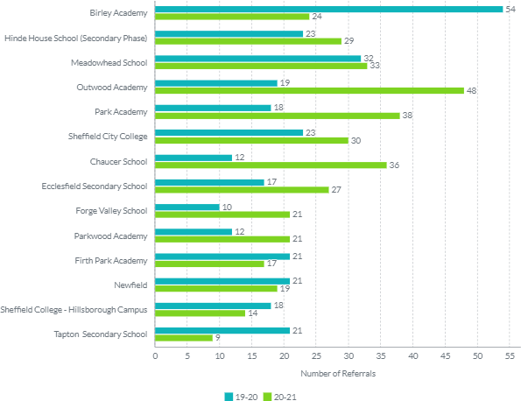

Figure 25: Pre-Schools with most referrals across two years
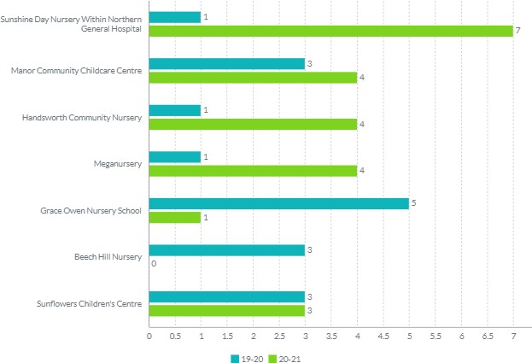

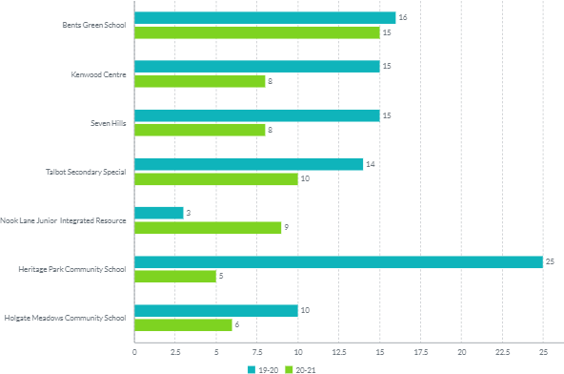
Figure 26: SEND settings with most referrals across two years

Figure 27: Other settings with most referrals across two years
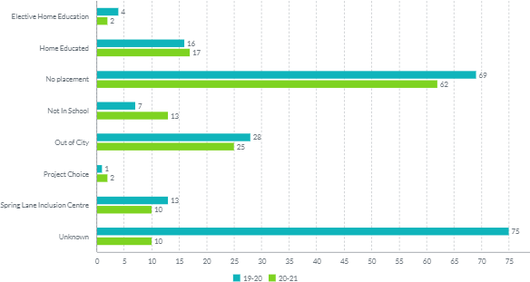

Social Media and Website information
We have continued to increase our social media and website usage to help offer self- service information for parents/ carers and young people. Our aim is to connect with as many parents, carers and young people in Sheffield as possible and to offer alternative methods of seeking support and advice with regards to SEND matters.
These are promoted during awareness sessions but via other service users and stakeholders. Depending on the subject area the reach of posts on social media varies in line with popularity. We continue to regularly post throughout the week.
Figure 28: Facebook followers Figure 29: Average reach on Facebook
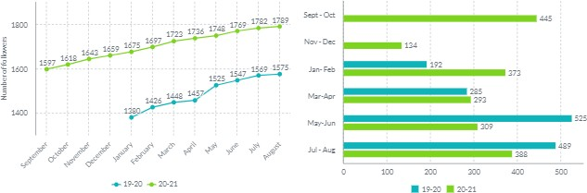

Figure 30: Top successful posts on Facebook by reach in 2021
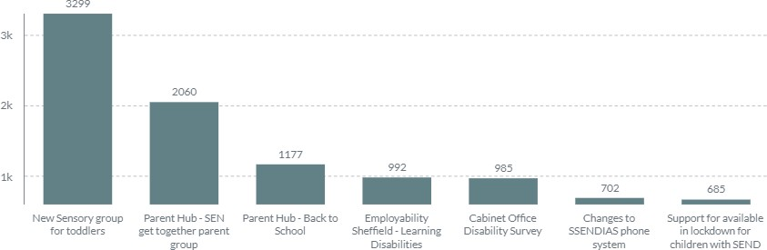

The website is stand alone and arm’s length from the Local Authority. It is a source of useful information, SEND laws and processes, ways to refer to our service, links to Sheffield Local Offer and training and events SSENDIAS are hosting. We have videos and webinars on: Who is SSENDIAS? and what can we do to support? for both parents/ carers and young people. A webinar of an Awareness session for Sheffield SSENDIAS. We are populating our website with FAQ’s webinars currently we have SEN Support in schools. This will be added to over the coming year.

Figure 31: Monthly visitor numbers to the SSENDIAS website 20-21
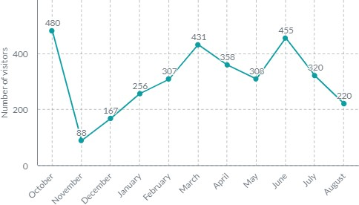

Figure 32: How did users find the website? (Oct 20-Dec 21)
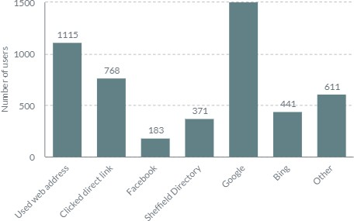

Figure 33: Number of page views (Oct 20- Dec 21)
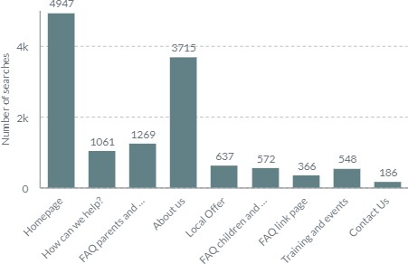

Service Users Evaluation Data
We send out evaluations to service users when a piece of work has been completed, the outcome parents/ carers or young people contacted our service for has been achieved or information has been sent. These are sent out monthly as a case closes. Even when a case closes, we have an open-door policy where a service user can come back to SSENDIAS at any given point in their child/ young person’s education (0-25) when further information, advice or support is needed.
We ask questions to find out the views and experiences of service users. Feedback is used in part as a self-review on how the service is delivering the information, advice and support responsibilities as required by the Children and Families Act 2014 and the SEN Code of Practice 2015. It also assists the future planning of the service and understanding the impact the advice and support may have had.
The questions included in the survey are designed by the Information, Advice and Support Network (IASSN) and are sent out as part of a wider national survey of participating IAS services in England to benchmark their performance.
Figure 34: Evaluation responses by postcode (Jan-Aug 2021)
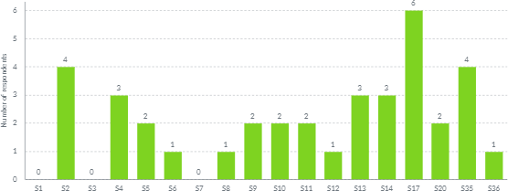

Figure 35: How easy was it to get in touch (Jan-Aug 21) Figure 36: How helpful was the information,
advice and support we gave? (Jan-Aug 21)
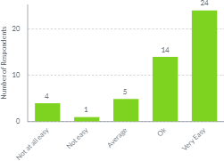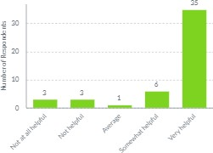

Figure 37: How neutral, fair and unbiased do you think we were? (Jan- Aug 21)
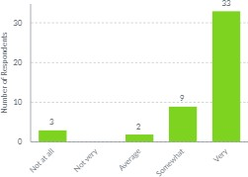

Figure 39: How likely is it that you would recommend the service to others? (Jan-Aug 21)
Figure 38: What difference do you think our information, advice or support has made? (Jan-Aug 21)
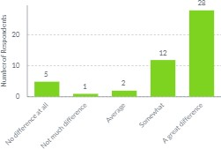

Figure 40: Overall how satisfied are you with the service we gave? (Jan-Aug 21)

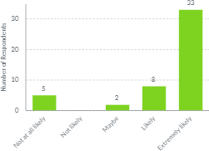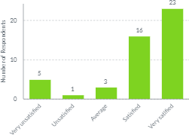

“SSENDIAS service made a hard situation an easy experience. It was no trouble to the case worker, who went the extra mile to help and support us.”
“Good service & the only support I have at a very difficult time”

“I have found this service, so helpful for myself and the families I work within the community.”

“Thank you so much for all your help. It is very much appreciated. Excellent support with kindness and understanding in the difficult circumstances we find ourselves in. So good to know this service is here to depend on.”
“The case workers work really hard but there aren't enough of them for the amount of work that they have to do. Particular thank to my worker who has helped us hugely”

“We found the people who we spoke to very knowledge able and polite and very understanding.
Brilliant service”

“In the past I have had excellent support from Ssendias and not so good, this was down to the individual case worker. This time I would say things are
worse as I've not even been allocated a case worker.”
“We’ve not received the call we were told we would get in a week, that was about 3 weeks ago”

Conclusion
This past academic year has been another busy year for Sheffield SENDIAS. Despite the restrictions due to COVID-19 SSENDIAS has continued to see an increase in the number of referrals we receive from parents/ carers who have used the service before and from new referrals.
Due to capacity within SSENDIAS we are busy reviewing the way we respond to enquiries and the structure of the service. These changes will be implemented over the coming months and will find more capacity within the service to maintain a good response time as numbers of referrals intensified. Due to the substantial increase in referrals year on year we now have waiting lists for contact. The initial referral is taken within 3 working days and to have a response to that enquiry is approximately 3 weeks. Referrals for statutory work is prioritised for a response within the legal timescales.
We are still working from home and virtual meetings are the preferred way to attend a meeting. This supports increasing capacity for caseworkers. We also use virtual meetings to support with working through documents and helping parents/ carers and children & young people express their views.
Over COVID-19 we have ensured we provide accurate information, advice, and support by keeping up to date with legislative changes and disseminating this through our social media and website. This has meant additional training for the team adding to its capacity and time of the team.
The increase in demand for the service is due to:
    - Development of Sheffield SENDIAS from 2018 due to additional grant funding from CDC (Council for Disabled Children) and DfE (Department for Education) which has increased awareness of the service, therefore increased referrals.
    - An increase in demand for children and young people in Sheffield
    - Changes to ways of working for children with home education taking place over lock downs.
    - Changes to legislation due to COVID-19.
    - The team working from home and learning to adapt to new ways of working.
    - The commitment from the team to deliver a quality information, advice and support service.
To improve further we plan to work with our steering group with close links to parent/carers and young people and key stakeholders to develop a sustainable service for the future. We will also be discussing this with commissioners from the Local Authority and CCG (Clinical Commissioning Group). This is to ensure Sheffield SENDIAS can continue meeting the minimum standards and local need.

